A
PROJECT REPORT
ON
FOOD
Delivery
SYSTEM

Submitted
By
[ZhaoJianfeng]
[LiRen]
[YangHaiyu]
.
.
.
.
.
.
.
.
Hainu university
PROJECT INDEX
S no. | Particulars | Page no.
1 | About the food delivery requirement, SDLC | 1-3
2 | About the modules:-  Login module  Order dishes module  Payment and Confirm order module | 3-4
4 | Datebase | 4-5
5 | DFD of Login Module | -06-
6 | DFD of Order dishes module | -07-
7 | DFD of Payment and Confirm order module | -08-
8 | Snapshots  Login module  Profile Management Module  Recruitment Module | -09-  -10-  -11-
9 | Source code of Login module  UserLoginDBobj.java  USerLoginDBMethods.java  Hrms_User_Login.java  Hrms_User_Login.jsp  Hrms_User_Login_Pswd_Change.jsp  Hrms_Default.jsp  Hrms_Footer.jsp  Hrms_Header.jsp  Hrms_Main_Menu.jsp

PROJECT REPORT

FOOD
DELIVERY
SYSTEM
Time in the fast-paced modern life is precious to anyone, and wasting a lot of time on the way to dinner is like waiting for a red light or looking for a favorite restaurant. So we developed a system through which users can easily choose their favorite foods and purchase them online. The third party rider then sends the product selected by the user to the user.

Software Requirements
- J2sdk1.6
- Web Logic Server
- MySql
- Any IDE like Eclipse3.2 or NetBeans 5.1

SDLC of the Project
This project is a web application and going to be developed using traditional Java technology similar to all other software projects, this project too has its own software development like cycle. The SDLC of this project will be discussed under the following heads.

Requirement Analysis
Before starting the project, first consideration should be given to the need for the new system to fill in the requirements can be through the analysis of the original system to reveal its problems, the so-called demand analysis. Needs analysis is a top priority for any development project that needs to be considered before we need to set the goals for the project in advance. And the analysis found that users may face problems in use and solutions. We can use questionnaires to find out the problems that users face. And we will follow up and upgrade the system through the questions expressed in the questionnaire, and deal with all possible problems in use such as:
- Entering, storing and searching of employing information manually are time consuming and error prone process:Stores manually enter store information and various information such as pictures of goods and prices are often the most prone to errors. At this time, stores need to set up special employees to verify and reupload data. And the store's new employees also need to deal with the store's employees. And contact the developer if you have a problem.

- The second task which is very important is the payment module: This part concerns the security of the user's property. Therefore, the system provides docking with Alipay and WeChat platforms. Therefore, users can pay in these two ways. Of course, the security of these two platforms is unquestionable to provide users with a convenient and safe way to pay.
Software Design
Software design is a solution- “how to approach the creation of a new system”. This important phase is composed of several steps. It provides the understanding and procedural details necessary for implementing the system recommended in the feasibility study.

In software design, there are three distinct types of activities:
- External design
- Architectural design
- Detailed design

External Design
The external design of the software includes the design, planning, and designation of external observable features of the software product. These features include user display, report format, external data sources, functional requirements, performance requirements, and advanced process structures for the product.
The external design begins at the analysis stage and continues at the design stage.
Internal Design
Internal design includes designing, planning and specifying the internal structure and handling details of software products. The goal of the internal design is to define the internal structure and process details, document design decisions, explain why certain alternatives and trade-offs are selected, develop test plans, and provide a blueprint for implementation, testing and maintenance activities.
Architectural design
Architecture design involves perfecting the concept view of the system, identifying internal processing functions, decomposing high-level functions into sub-functions, defining internal data flows and data storage, and establishing relationships and interconnections between functions, data flows, and data storage.

The software will be designed according to each module to fully meet all of the requirements that we put forward in the requirements analysis. The entire system can be divided into multiple modules. The following modules can be identified in this project:

- Login module
- Order dishes module
- Payment and Confirm order module

Login module
This module ensures that all access to the system is correct and authenticated. All links and navigation paths can be used to manipulate any information only after the authorized person has entered a valid set of user names and passwords. Therefore, this module serves as an entry point to the system and is accessible only to authorized personnel.

Order dishes module
This module provides users with the choice of favorite stores and free choice of products. This module will calculate the amount of money to be paid in real time based on the goods ordered by the user.
Payment and Confirm order module
This module is mainly responsible for receiving address information filled in by users and uploading it to the cloud for delivery to stores and take-out delivery personnel. This module is also where users trade their money to businesses through Alipay or WeChat.

Database Design
The whole project is in fact an information management system, which interacts with the database having a number of tables. The tables with their column names and data type are as follows.

HRMS_USER_LOGIN
Field Name | Data Type | Size | Primary Key | Null
USER_ID | Varchar2 | 10 | Y | N
USER_NAME | Varchar2 | 30 |  | N
OLD_PSWD | Varchar2 | 10
NEW_PSWD | Varchar2 | 10
PSWD_EFF_DATE | Date
PSWD_EXP_DATE | Date

HRMS_EMPLOYEE
Field Name | Data Type | Size | Primary Key | Null
EMP_ID | Varchar2 | 10 | Y | N
EMP_F_NAME | Varchar2 | 20
EMP_M_NAME | Varchar2 | 20
EMP_L_NAME | Varchar2 | 20
ORG_ID | Varchar2 | 10
LEVEL_ID | Varchar2 | 10
DEPT_ID | Varchar2 | 10
DOB | Date
DOJOIN | Date
ADDRESS_1 | Varchar2 | 50
ADDRESS_2 | Varchar2 | 50
CITY | Varchar2 | 15
STATE | Varchar2 | 20
NATIONALITY | Varchar2 | 15

HRMS_APPLICANT
Field Name | Data Type | Size | Primary Key | Null
APPLICANT_ID | Varchar2 | 10 | Y | N
APPLICANT_NAME | Varchar2 | 50 |  | N
ADDRESS_1 | Varchar2 | 100
ADDRESS_2 | Varchar2 | 100
EMAIL |  | 50
PHONE | Number | 15
MOBILE | Number | 11
DOB | Date
GENDER |  | 10

Data Flow Diagram:-

DFD of Login module

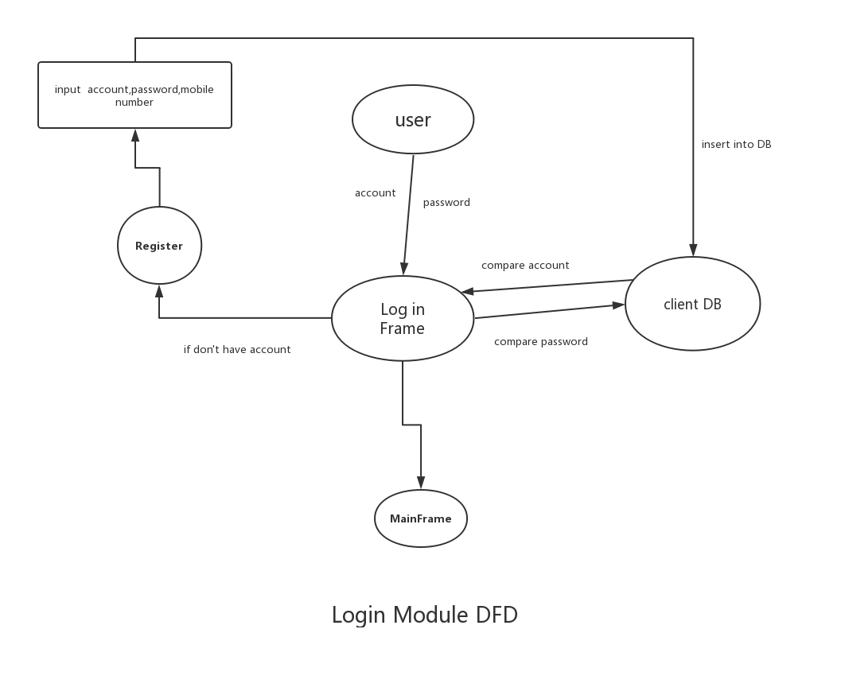

DFD of Order dishes module

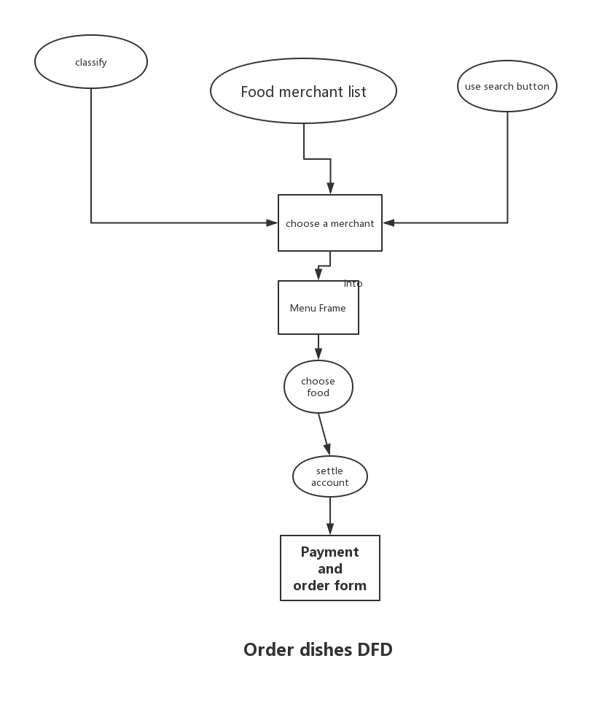

DFD of Payment and Confirm order module

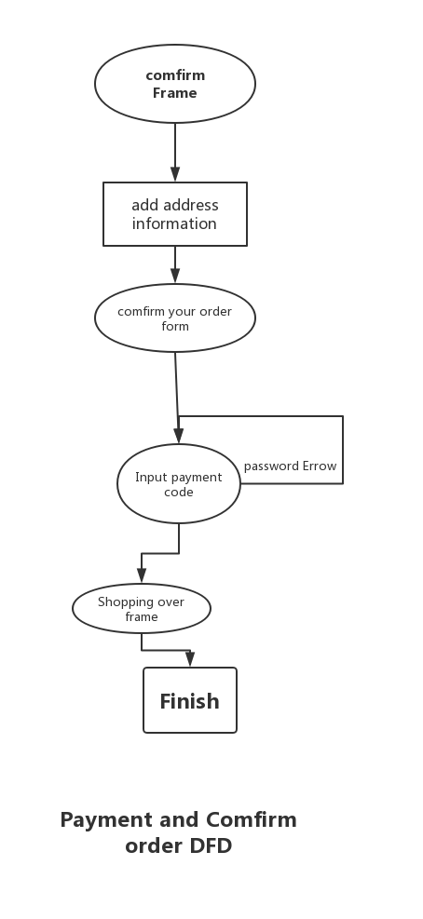

Login module

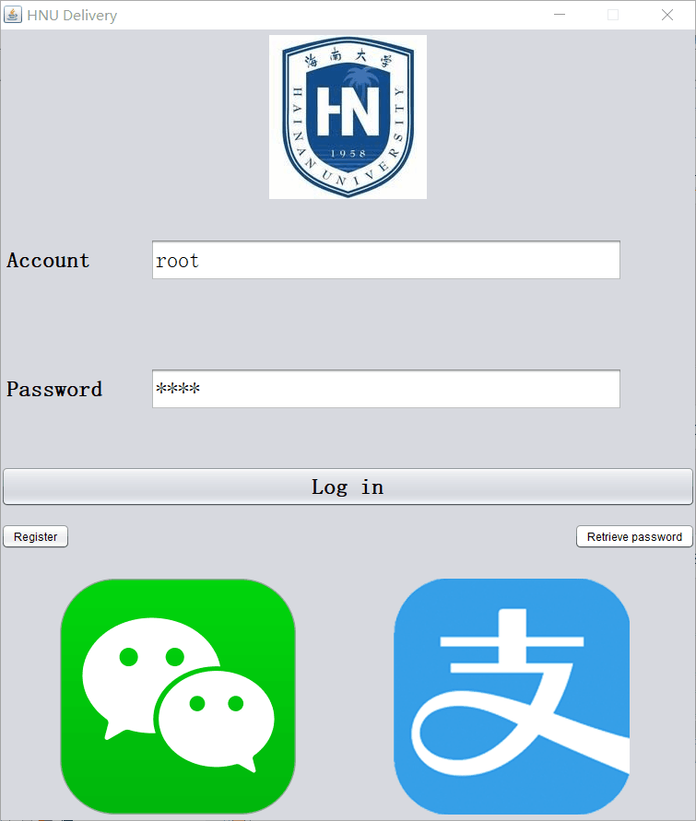

Order dishes module

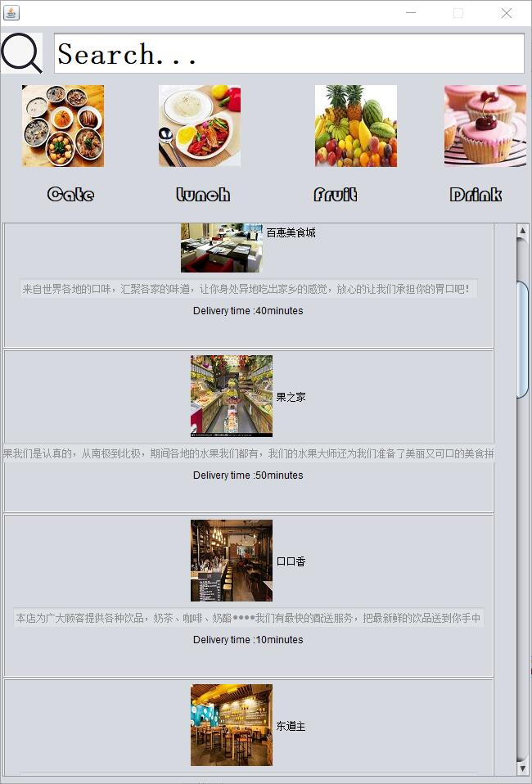
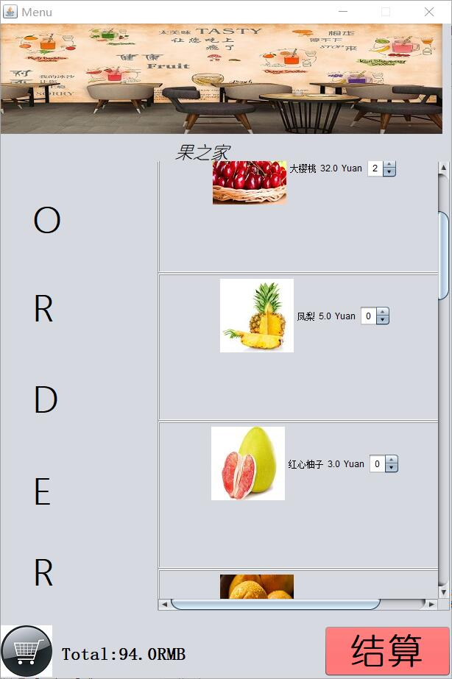

DFD of Payment and Confirm order module

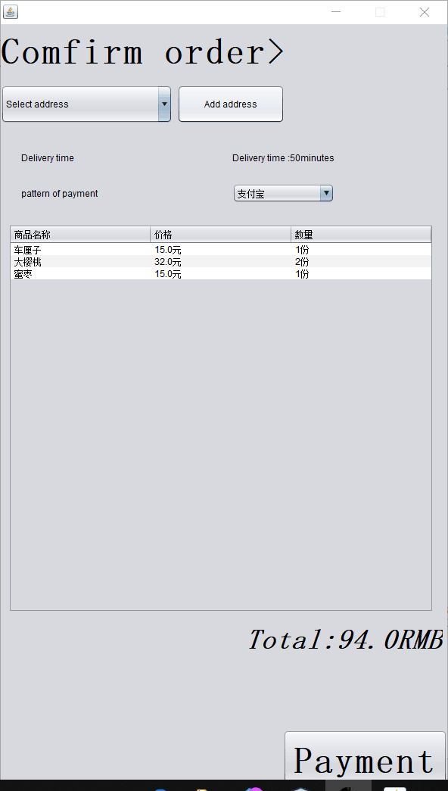

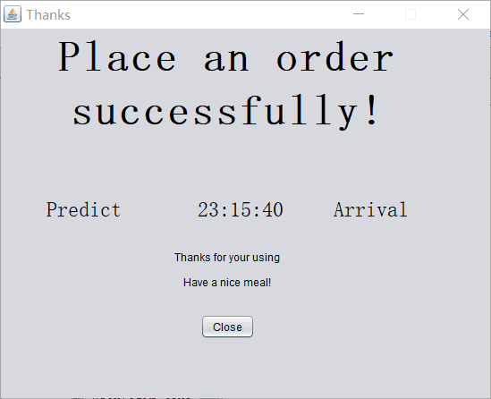

Code of UserLoginDBobj.java

Code of USerLoginDBMethods.java

Code of Hrms_User_Login.java

Code of Hrms__User_Login.jsp

Code of Hrms_User_Login_Pswd_Change.jsp

</html>

Code of Hrms_Footer.jsp

Code of Hrms_Header.jsp

Code of Hrms_Main_Menu.jsp

